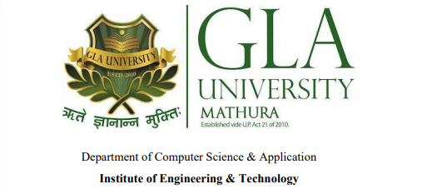

**SECRET COMMUNICATION IN MULTIMEDIA FORENSICS**

**A PROJECT REPORT**

***Submitted by***

ADITI SARASWAT GAGAN TIWARI KAMINI SENGAR PRIYANKA SINGH

( 201530002 ) ( 201530011) ( 201530015 ) ( 201530021 )

***in partial fulfillment for the award of the degree of***

### BACHELOR OF TECHNOLOGY

**IN**

**COMPUTER SCIENCE**

SESSION – 2022-2023

**GLA University, Mathura**

NOVEMBER 2022

#### BONAFIDE CERTIFICATE

Certified that this project report **“SECRET COMMUNICATION IN MULTIMEDIA FORENSICS”** is the bonafide work of “**ADITI SARASWAT, GAGAN TIWARI, KAMINI SENGAR, PRIYANKA SINGH”** who carried out the project work under my/our

|  |  |
| --- | --- |
| supervision.    <<Signature of the HOD>>  **SIGNATURE** : ROHIT AGRAWAL  **HEAD OF THE DEPARTMENT**  <<Department>> Computer Science Engineering (CSE) | <<Signature of the Supervisor>>  **SIGNATURE** : Mr. Ajeet Kumar Sharma    <<Name>>  **SUPERVISOR**  <<Academic Designation>>  **ASSISTANT PROFESSOR**    <<Department>> Computer Science Engineering (CSE) |
|  |  |

**ACKNOWLEDGEMENT**

It gives us a great sense of pleasure to present the synopsis of the BTech mini project undertaken during BTech IIIrd Year. This project is going to be an acknowledgement to the inspiration, drive and technical assistance will be contributed to it by many individuals. We owe special debt of gratitude to Mr. Ajeet Kumar Sharma(our mentor) for providing us with an encouraging platform to develop this project, which thus helped us in shaping our abilities towards a constructive goal and for his constant support and guidance to our work.

His sincerity, thoroughness and perseverance has been a constant source of inspiration for us. We believe that he will shower us with all his extensively experienced ideas and insightful comments at different stages of the project & also taught us about the latest industry-oriented technologies. We also do not like miss the opportunity to acknowledge the contribution of all faculty members of the department for their kind guidance and co-operation.

# TABLE OF CONTENTS

1. **INTRODUCTION**

1.1)Objective

1.2)Motivation

1.3)Problem Statement

1. **SCOPE**
2. **FEATURES**
3. **PROBLEM STATEMENT**
4. **REQUIREMENTS**

5.1)Hardware Requirements

5.2)Software Requirements

5.3)Technology Stack

1. **PROJECT DESCRIPTION**
2. **DATA FLOW DIAGRAM**
3. **IMPLEMENTATION**
4. **DESIGN FLOW/PROCESS**

**10.EXPERIMENTS AND RESULTS**

**11.CONCLUSIONS AND FUTURE WORK**

**12.REFERENCES**

12.1) Web pages

12.2)GitHub Repository Link

**1.INTRODUCTION**

* 1. **Objective:** StegIMG is a pure JavaScript steganography tool designed in functional programming style, to hide secrets inside image by compressing and encrypting the secret with special unicode invisible characters. It can be used to safely watermark strings, invisible scripts on webpages, texts on social media or for any other covert communication.

* 1. **Motivation**: We wanted to try something new and challenging while doing our firs mini project. So, we decided to create something that can be used on the regular basis and an application that has a on ground application, and from there only we got this idea in our mind and now we are working on it to implement this as soon as possible.
  2. **Problem Statement:** In this project we are hiding secrets with invisible characters in an image.

Behind the scenes steganography.js uses an algorithm to convert the given message into appropriate binary data which then will be hidden in the alpha channel of the given cover image. A HTML5 canvas element is then used to process the data and the image. To decode a message from a given image, a similar algorithm is applied on the image data.

**2.SCOPE**

* The scope of the project is to limit unauthorized access and provide better security during message transmission. To meet the requirements, we use the simple and basic approach of steganography.
* In this project, a JavaScript library steganography.js is used to encode secret messages inside images and to decode them again.
* Steganography.js works on every browser which supports the HTML5 canvas element. However, it has been tested on Chrome, Opera, IE 9, Firefox and Safari.

**3.FEATURES**

* Protect our invisible secret by embedding it to the source image.
* Works on every browser which supports the HTML5 canvas element.
* Easy to use library. You just have to add the .js-file to your website and by now you can make use of the global object steganography or short steg and the two provided functions encode and decode.
* Written in pure functional style.
* This tool creates a canvas with your image, and an identically sized canvas with your text. It then searches through each pixel of the text canvas, if it sees black, it knows the pixel it's viewing is part of the message.

**4.PROBLEM STATEMENT**

How can we send a message secretly to the destination. Using steganography, information can be hidden in carriers such as images, audio files, text files, videos and data transmissions. For the proposal of a new framework of an image steganography system to hide a digital text of a secret message following points should be well considered:  
➢**Feasibility Study:** The proposed solution should satisfy all the user  
requirements and should be easy to use and the hidden message carried by stego-media should not be sensible to human beings. The other goal of steganography is to avoid drawing suspicion to the existence of a hidden message

➢ **Economical Feasibility**: We have estimated that the benefits the  
organization is going to receive from the proposed system will  
surely overcome the initial costs and the later on running cost for  
system.  
➢ **Technical Feasibility**: This included the study of function,  
performance and constraints that may affect the ability to achieve  
an acceptable system. For this feasibility study, we studied  
complete functionality to be provided in the system, as described  
in the System Requirement Specification (SRS), and checked if  
everything was possible using different type of frontend and  
backend platforms.

➢ **Time Feasibility:** We have estimated that our project title is reasonable given our technical expertise, a project deadline is reasonable.

**5.REQUIREMENTS**

* 1. **Hardware Requirements:**

Mobile Phone / Laptop / PC (with proper internet connectivity)

* 1. **Software Requirements**:

5.2.1) VS Code

5.2.2)Web Browser

* 1. **Technology Stack:**

5.3.1)HTML

5.3.2) CSS

5.3.3)JavaScript

5.3.4) Tailwind CSS

5.3.5)Steganography.js

**6.PROJECT DESCRIPTION**

This project is a purpose driven project, the main objective of the tool StegIMG is to limit unauthorized access and provide better security during message transmission. To meet the requirements, we use the simple and basic approach of steganography. In this project, the main concern is embedding the data into an image.

This project is accessible for two users:  
1. Sender: As an end user it will be a platform for you to choose an image and embed a secret text in it.

2. Receiver: As an end user it will be a platform for you to select the image containing secret text sent by the sender and decode the message.

**7.DATA FLOW DIAGRAM**

Image in which secret message is embedded

Secret message

Source Image

Secret Text

Stego-text

Level 0 DFD

Sender

Receiver

**8.IMPLEMENTATION**

This project is insight into the design and implementation of a steganography tool.  In the present world, the data transfers using internet is rapidly growing because it is so easier as well as faster to transfer the data to destination. So, many individuals and business people use to transfer business documents, important information using internet. Security is an important issue while transferring the data using internet because any unauthorized individual can access the data and make it useless or obtain information un- intended to him.  The primary aim of is to provide solutions for this problem by secretly communication via unsecure network. Today problem resolving is one of the most essential features of all form. This is steganography tool for secret communication using images which will provide solution for encryption and confidentiality of data.

#### 9.DESIGN FLOW/PROCESS

##### 9.1 PROPOSED METHODOLOGY.

##### Language Used: JavaScript

##### Library Used: steganography.js

##### Steganography technique Used: LSB steganography

##### 

##### 9.2. PROPOSED METHODOLOGY ARCHITECTURE.

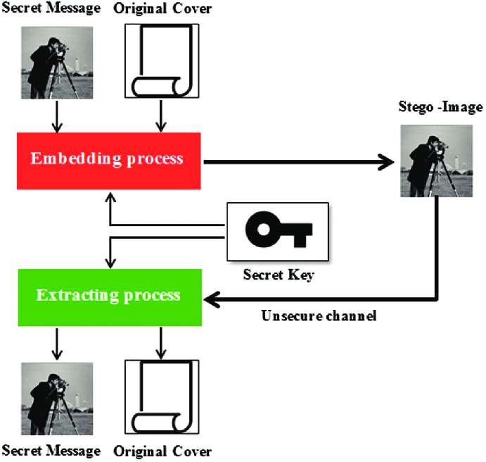

**9.3. DISCUSSION ON PROPOSED METHODOLOGY**

**Stego-Image**

A stego image is an image with a hidden message.

**Cover-Image**

Unique picture that can conceal data.



**Message**

Real data that you can mask within pictures. The message may be in the form of standard text or an image.

**Stego-Key**

Messages can be embedded in cover images and stego- images with the help of a key, or the messages can be derived from the photos themselves.

**10.EXPERIMENTS AND RESULTS**

#### Browser that supports HTLM5 Canvas element.

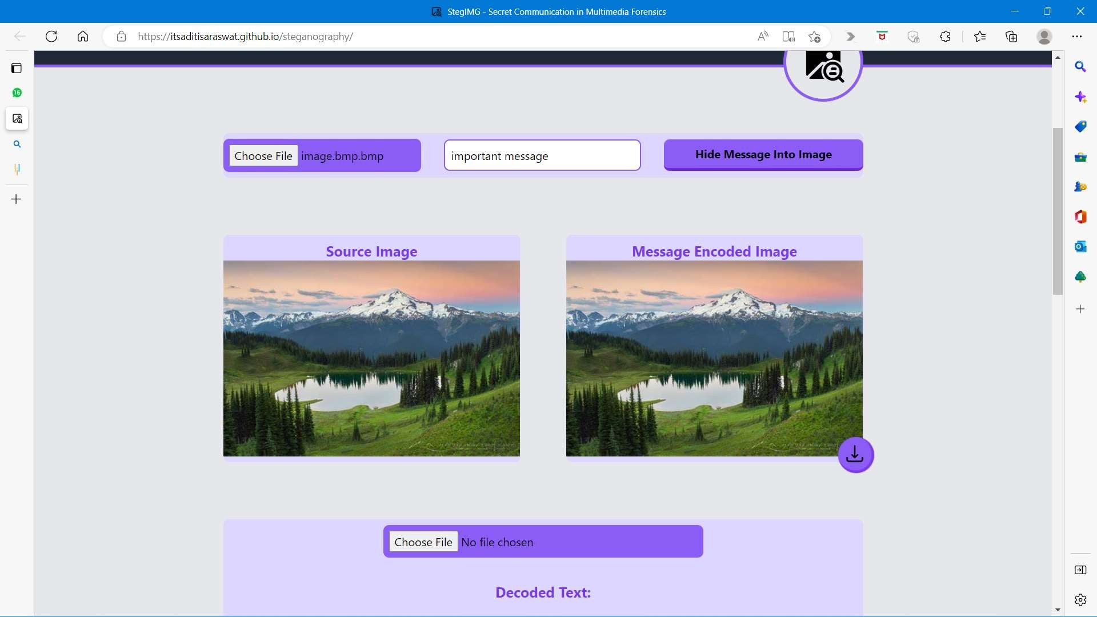

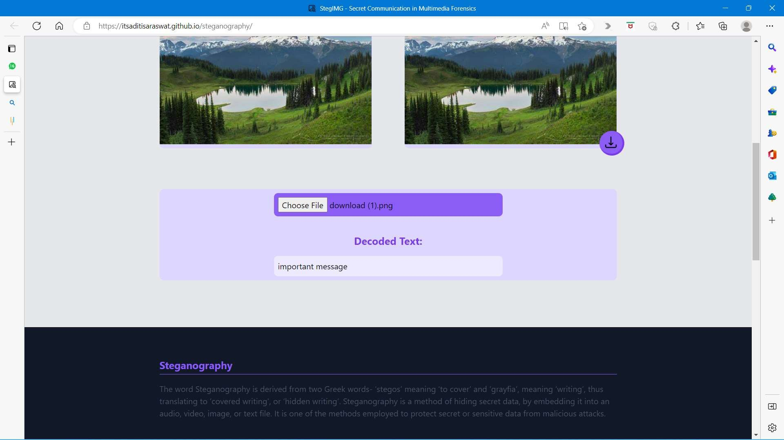

#### 11. CONCLUSION AND FUTURE WORK

* CONFIDENTIALITY
* INTEGRITY

In future, we are considering using audio files for hiding message for secret communication as StegIMG tool does not hide secret messages in audio files due to the lack of the appropriate tools. To achieve this, more extended tests are required in order to validate and confirm the outcomes derived in this work.

**12. REFERENCES**

* 1. Webpages:

www.google.com

[www.geekforgeeks.com](http://www.geekforgeeks.com)

www.peter-eigenschink.at/projects/steganographyjs/

* 1. GitHub Repository link:

**priyankasinghhhhh.github.io/StegIMG/**